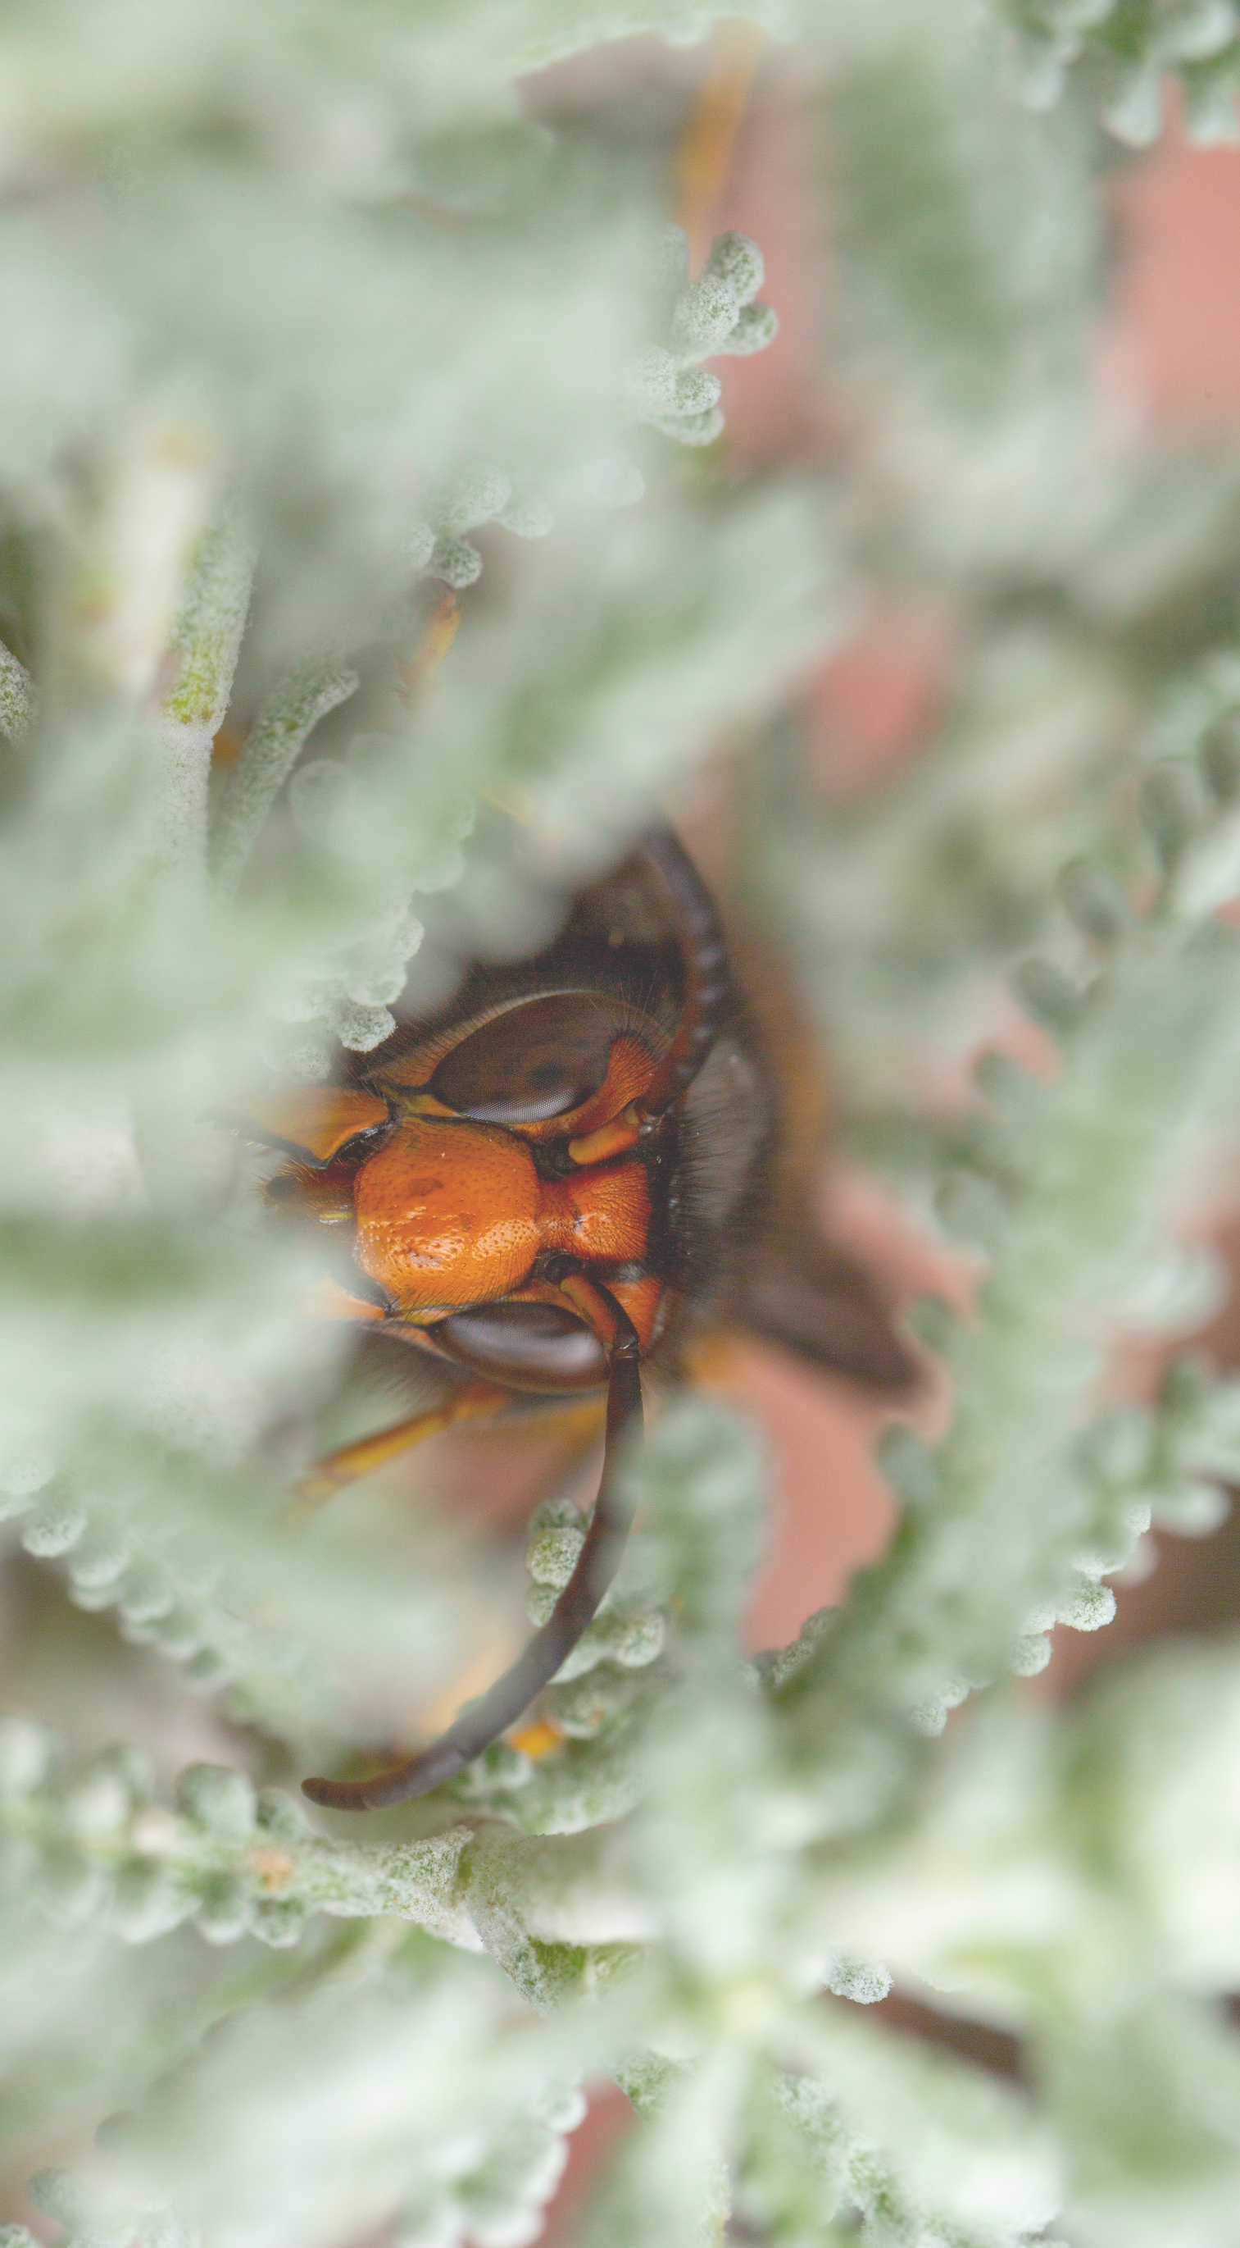 E X P L O R A T O R Y D A T A A N A L Y S I S ( E D A ) P R E S E N T A T I O N 

K O P U R U " V E S P A

C H A L L E N G E V E L U T I N A "

I E

X

L

D A T A S C I E

H T T P S : / / G I T H U B

. C O M / I E W A S

 I E D A T A S C I E N C E B O O T C A M P P T J A N - 2 0 2 1 

N C E T E A M

P B U S T E R S

 E X P L O R A T O R Y D A T A A N A L Y S I S ( E D A ) P R E S E N T A T I O N 

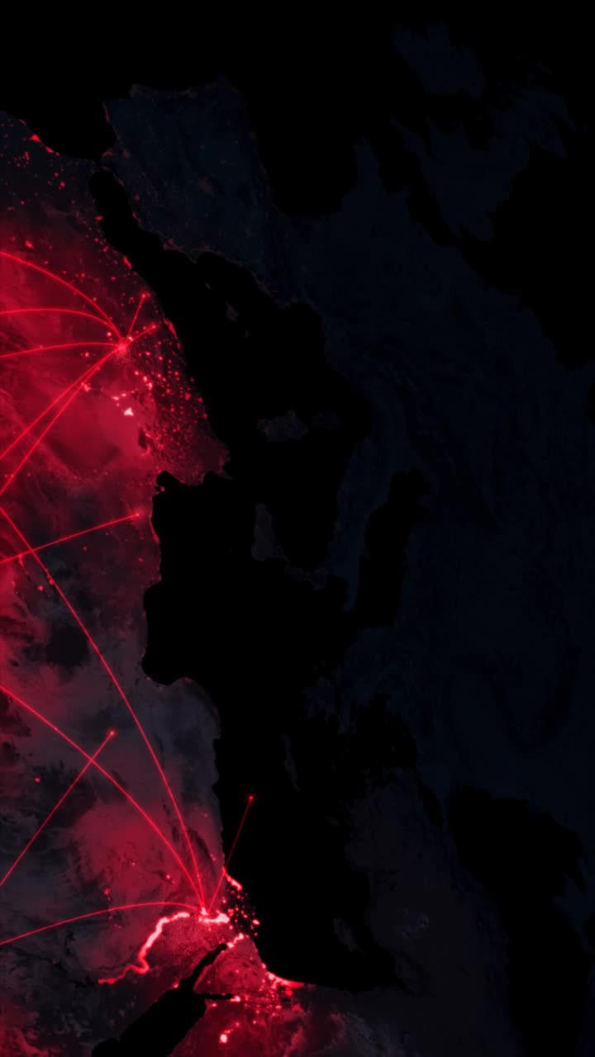

 I E D A T A S C I E N C E B O O T C A M P P T J A N - 2 0 2 1 







 



 E X P L O R A T O R Y D A T A A N A L Y S I S ( E D A ) P R E S E N T A T I O N 



 I E D A T A S C I E N C E B O O T C A M P P T J A N - 2 0 2 1 

 

# K O P U R U C H A L L E N G E

**V E S P A V E L U T I N A**

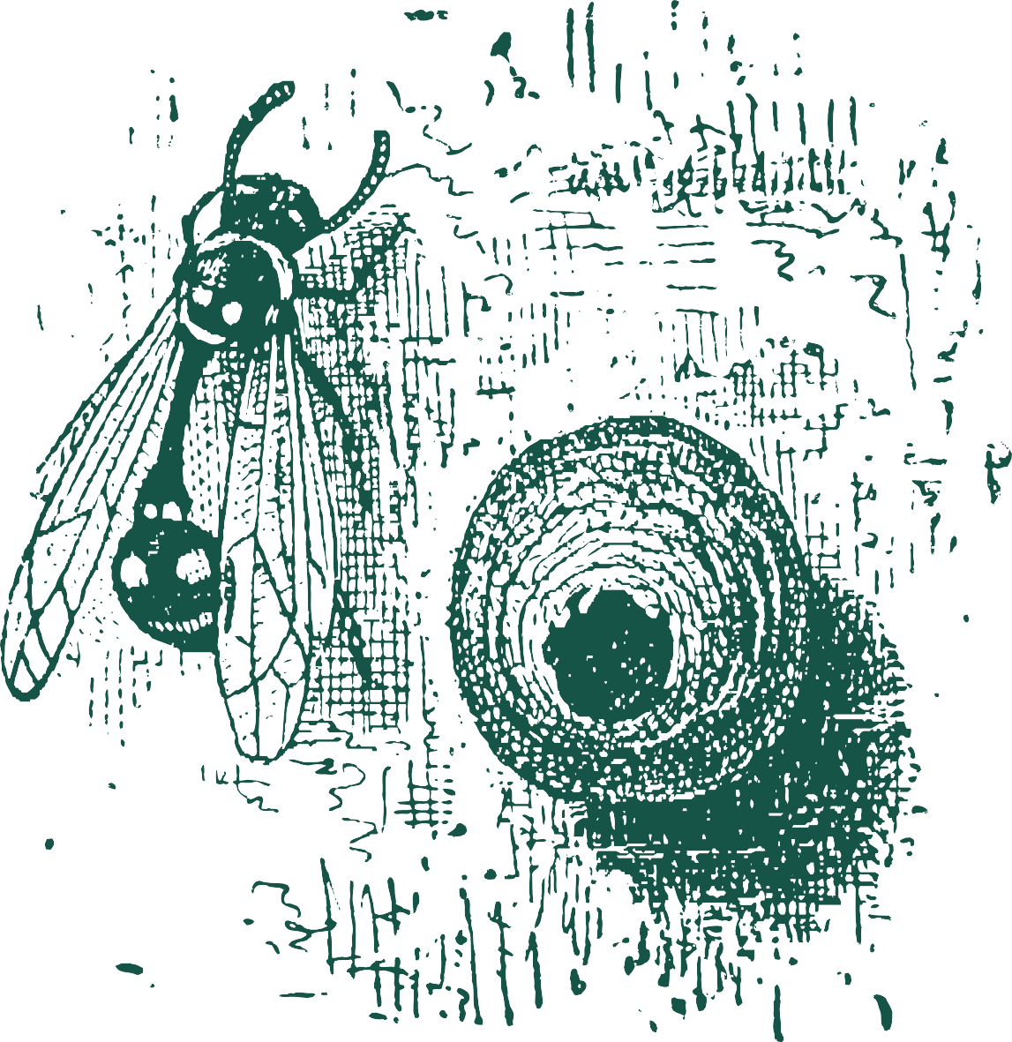

P R E S E N T A T I O N

*Opening remarks*

( E D A )

M P P T

J A N - 2 0 2 1

Of bees, and wasps… How’s the weather?

E X P L O R A T O R Y

D A T A

A N A L Y S I S

I E D A T A

S C I E N C E B O O T C A

Keep Calm and Data Science 



*Closing remarks*



 E X P L O R A T O R Y D A T A A N A L Y S I S ( E D A ) P R E S E N T A T I O N 

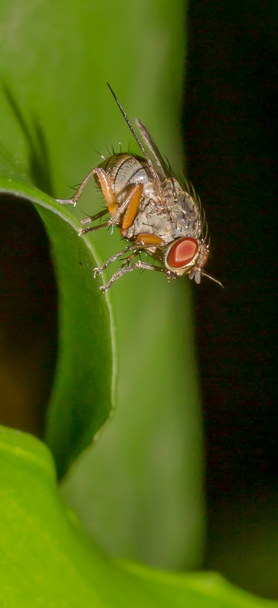

C O M M O N

F R U I T

O R

V I N E G A R

 I E D A T A S C I E N C E B O O T C A M P P T J A N - 2 0 2 1 

F L Y F L Y

 E X P L O R A T O R Y D A T A A N A L Y S I S ( E D A ) P R E S E N T A T I O N 

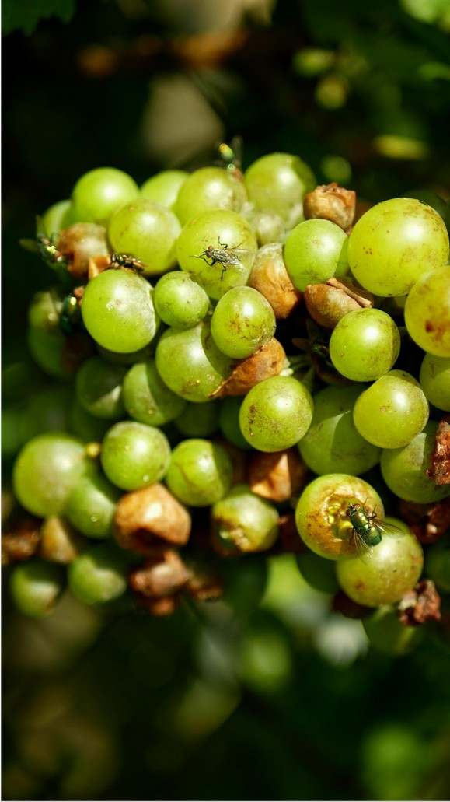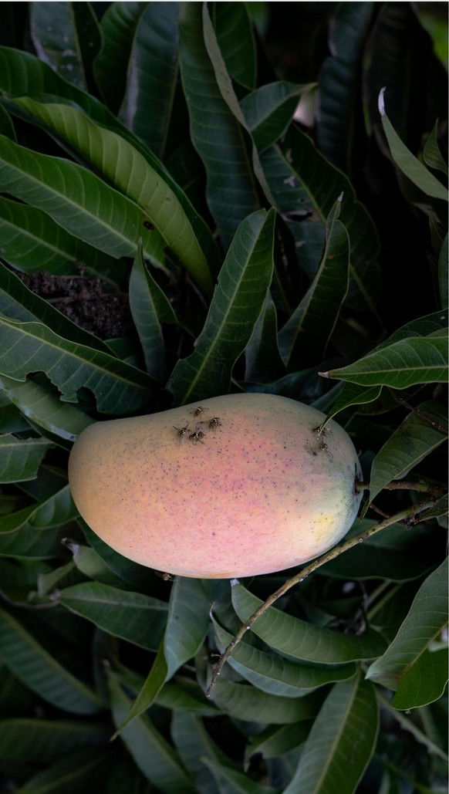

 I E D A T A S C I E N C E B O O T C A M P P T J A N - 2 0 2 1 

 E X P L O R A T O R Y D A T A A N A L Y S I S ( E D A ) P R E S E N T A T I O N 

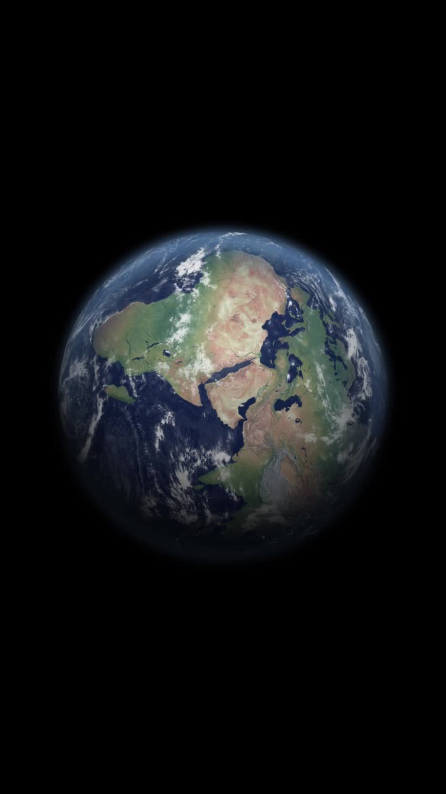

**Spain**

 I E D A T A S C I E N C E B O O T C A M P P T J A N - 2 0 2 1 

 E X P L O R A T O R Y D A T A A N A L Y S I S ( E D A ) P R E S E N T A T I O N 



 I E D A T A S C I E N C E B O O T C A M P P T J A N - 2 0 2 1 

 E X P L O R A T O R Y D A T A A N A L Y S I S ( E D A ) P R E S E N T A T I O N 

W H A T

I S

T H E

K O P U R U

C H A L L E N G E ?



 I E D A T A S C I E N C E B O O T C A M P P T J A N - 2 0 2 1 

 

A N A L Y S I S

( E D A )

M P P T

H O W M A N Y W A S P N E S T S A R E T H E R E I N E A C H O F T H E 1 1 2

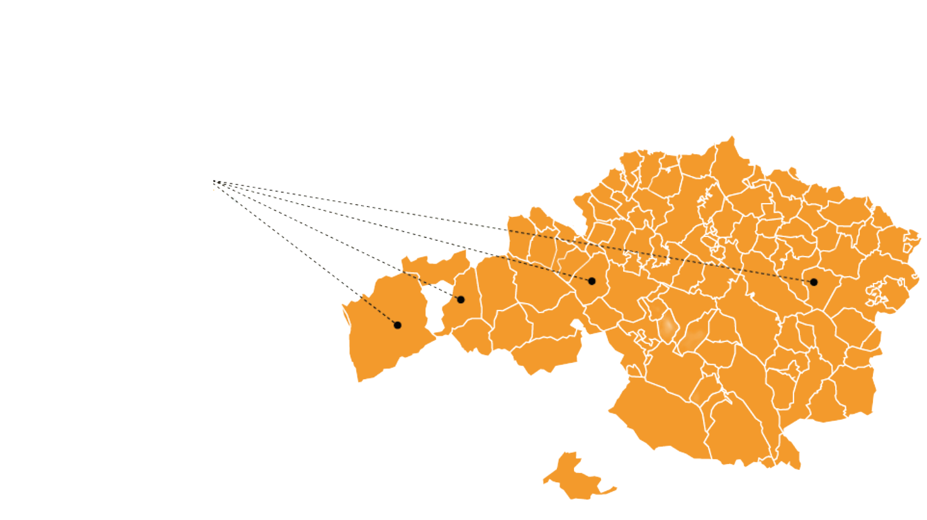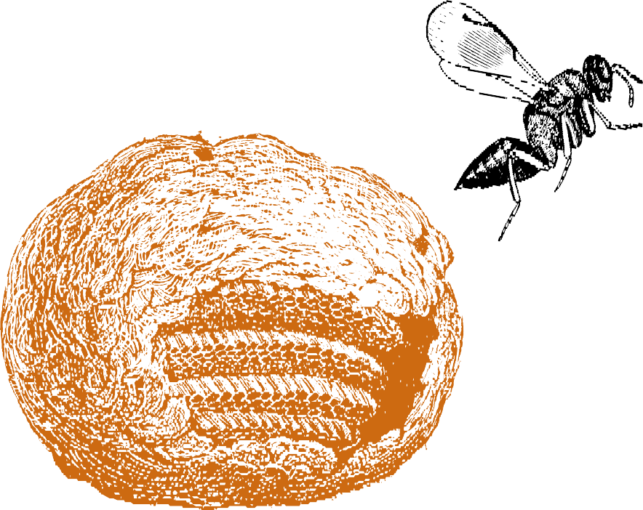

M U N I C I P A L I T I E S I N 2 0 2 0 ?

P R E S E N T A T I O N

J A N - 2 0 2 1

### Biscay, Spain

E X P L O R A T O R Y

D A T A

I E D A T A

S C I E N C E B O O T C A



 E X P L O R A T O R Y D A T A A N A L Y S I S ( E D A ) P R E S E N T A T I O N 

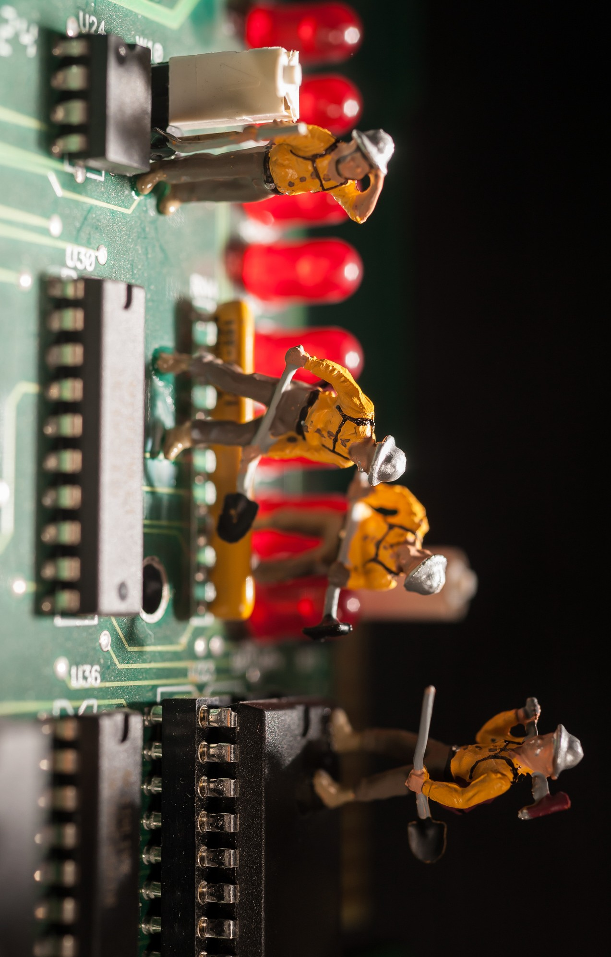

 I E D A T A S C I E N C E B O O T C A M P P T J A N - 2 0 2 1 

 E X P L O R A T O R Y D A T A A N A L Y S I S ( E D A ) P R E S E N T A T I O N 

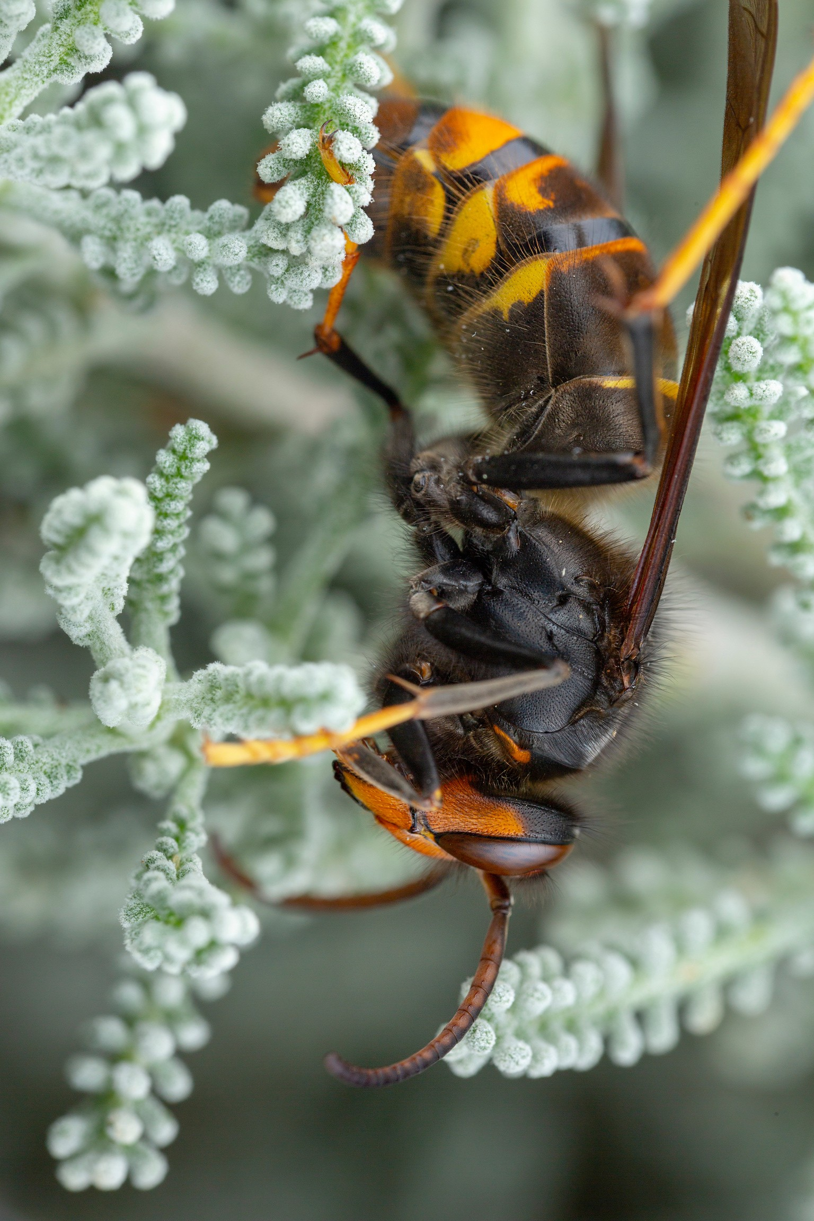

V E S P A

 I E D A T A S C I E N C E B O O T C A M P P T J A N - 2 0 2 1 

V E L U T I N A

 

# O F B E E S , A N D

**Vespa Velutina is native to Southeast Asia.**

**Accidentally arrived in Europe (France) in**

**2010 via import ship.**

**Negative impact:**

**Ecosystem. Beekeeping Industry. Health Hazard.**

A N A L Y S I S

( E D A )

P R E S E N T A T I O N

S C I E N C E B O O T C A

M P P T

J A N - 2 0 2 1

W A S P S …

E X P L O R A T O R Y

D A T A

I E D A T A



 

**W H A T I S N E E D E D F O R V E S P A V E L U T I N A T O T H R I V E ?**



# O F B E E S , A N D



A N A L Y S I S

( E D A )

P R E S E N T A T I O N

W A S P S …

E X P L O R A T O R Y

D A T A

**No Enemies:**

**No natural predators**

J A N - 2 0 2 1

**Food:**

M P P T

**Honey bees**

S C I E N C E B O O T C A

**Carbohydrates from flowers and fruits.**

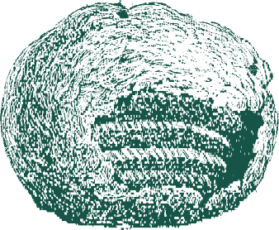**Housing and Surroundings: Protection from rain and winds.**

I E D A T A

 

 E X P L O R A T O R Y D A T A A N A L Y S I S ( E D A ) P R E S E N T A T I O N 

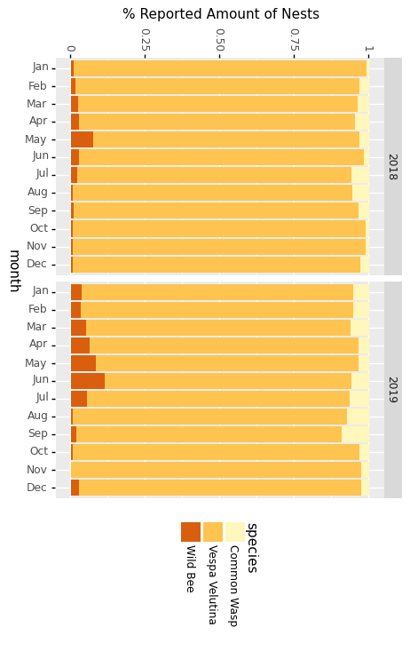

**O B S E R V E D**

**S P E C I E S**

**B Y**

**M O N T H**

**A N D**

**Y E A R**

 I E D A T A S C I E N C E B O O T C A M P P T J A N - 2 0 2 1 

 

**W H A T I S N E E D E D F O R V E S P A V E L U T I N A T O T H R I V E ?**



# O F B E E S , A N D



**No Enemies:**

**No natural predators**

**Food:**

**Honey bees**

**Carbohydrates from flowers and fruits.**

**Housing and Surroundings:**

**Protection from rain and winds.**



A N A L Y S I S

( E D A )

P R E S E N T A T I O N

S C I E N C E B O O T C A

M P P T

J A N - 2 0 2 1

W A S P S …

E X P L O R A T O R Y

D A T A

I E D A T A

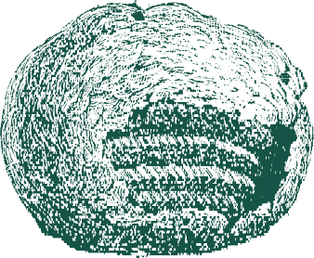



 E X P L O R A T O R Y D A T A A N A L Y S I S ( E D A ) P R E S E N T A T I O N 

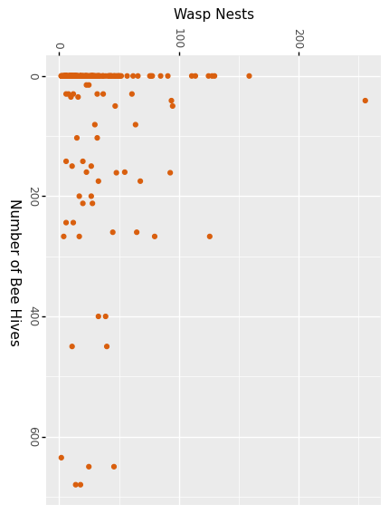

**F O O D :**

**N E S T S**

**V S**

**B E E**

**H I V E S**

 I E D A T A S C I E N C E B O O T C A M P P T J A N - 2 0 2 1 

 E X P L O R A T O R Y D A T A A N A L Y S I S ( E D A ) P R E S E N T A T I O N 

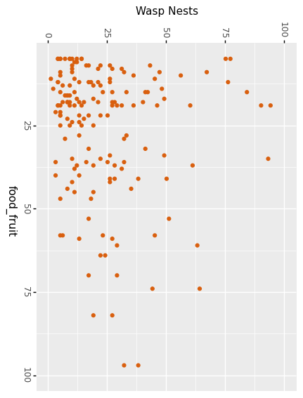

**F O O D :**

**N E S T S**

**V S**

**F R U I T S**

 I E D A T A S C I E N C E B O O T C A M P P T J A N - 2 0 2 1 

 

**W H A T I S N E E D E D F O R V E S P A V E L U T I N A T O T H R I V E ?**



# O F B E E S , A N D



**No Enemies:**

**No natural predators**

**Food:**

**Honey bees**

**Carbohydrates from flowers and fruits.**

**Housing and Surroundings:**

**Protection from rain and winds.**



A N A L Y S I S

( E D A )

P R E S E N T A T I O N

S C I E N C E B O O T C A

M P P T

J A N - 2 0 2 1

W A S P S …

E X P L O R A T O R Y

D A T A

I E D A T A

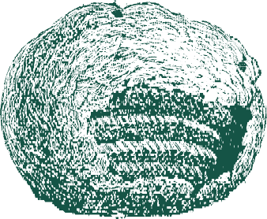



 E X P L O R A T O R Y D A T A A N A L Y S I S ( E D A ) P R E S E N T A T I O N 

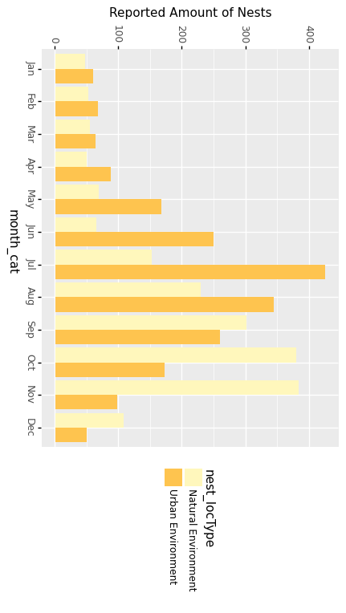

**H O U S E :**

**N E S T S**

**B Y**

**L O C A T I O N**

**T Y P E**

 I E D A T A S C I E N C E B O O T C A M P P T J A N - 2 0 2 1 

 

**W H A T I S N E E D E D F O R V E S P A V E L U T I N A T O T H R I V E ?**

# H O W ' S T H E



 

**Water is Key:**

**Proximity to rivers. Humid environment.**

**Springtime temperature: Not to hot, not to cold.**

D A T A

A N A L Y S I S

( E D A )

P R E S E N T A T I O N

S C I E N C E B O O T C A

M P P T

J A N - 2 0 2 1

W E A T H E R ?

E X P L O R A T O R Y

I E D A T A









 E X P L O R A T O R Y D A T A A N A L Y S I S ( E D A ) P R E S E N T A T I O N 

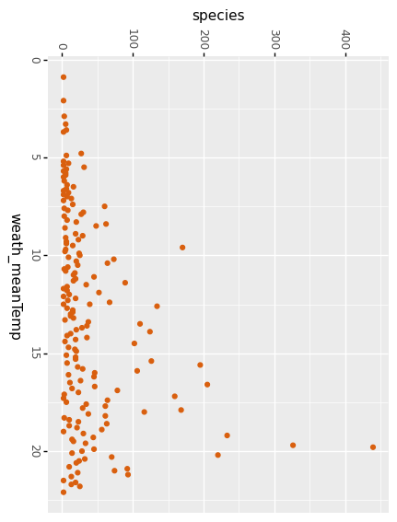

**W E A T H E R :**

**N E S T S**

**V S**

**M E A N**

**T E M P .**

 I E D A T A S C I E N C E B O O T C A M P P T J A N - 2 0 2 1 

 

**W H A T I S N E E D E D F O R V E S P A V E L U T I N A T O T H R I V E ?**

# H O W ' S T H E



**Springtime temperature: Not to hot, not to cold.**

**Water is Key:**

**Proximity to rivers. Humid environment.**

D A T A

A N A L Y S I S

( E D A )

P R E S E N T A T I O N

S C I E N C E B O O T C A

M P P T

J A N - 2 0 2 1

W E A T H E R ?

E X P L O R A T O R Y

I E D A T A



 E X P L O R A T O R Y D A T A A N A L Y S I S ( E D A ) P R E S E N T A T I O N 

**H Y D R O G R A P H Y**

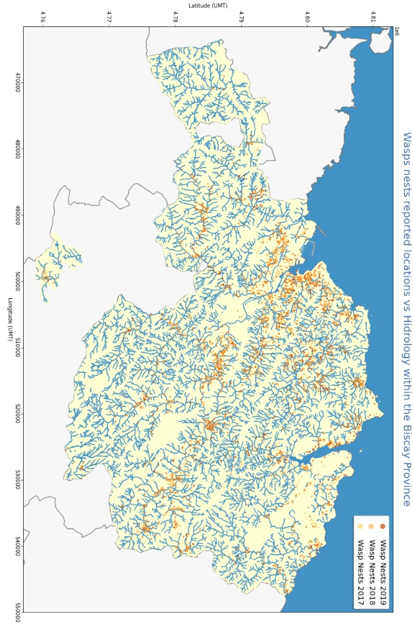

 I E D A T A S C I E N C E B O O T C A M P P T J A N - 2 0 2 1 

 E X P L O R A T O R Y D A T A A N A L Y S I S ( E D A ) P R E S E N T A T I O N 

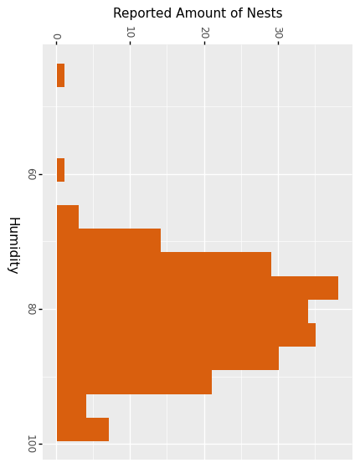

**W E A T H E R :**

**N E S T S**

**V S**

**%**

**H U M I D I T Y**

 I E D A T A S C I E N C E B O O T C A M P P T J A N - 2 0 2 1 

 E X P L O R A T O R Y D A T A A N A L Y S I S ( E D A ) P R E S E N T A T I O N 

W H I C H

W E A T H E R

S T A T I O N ?

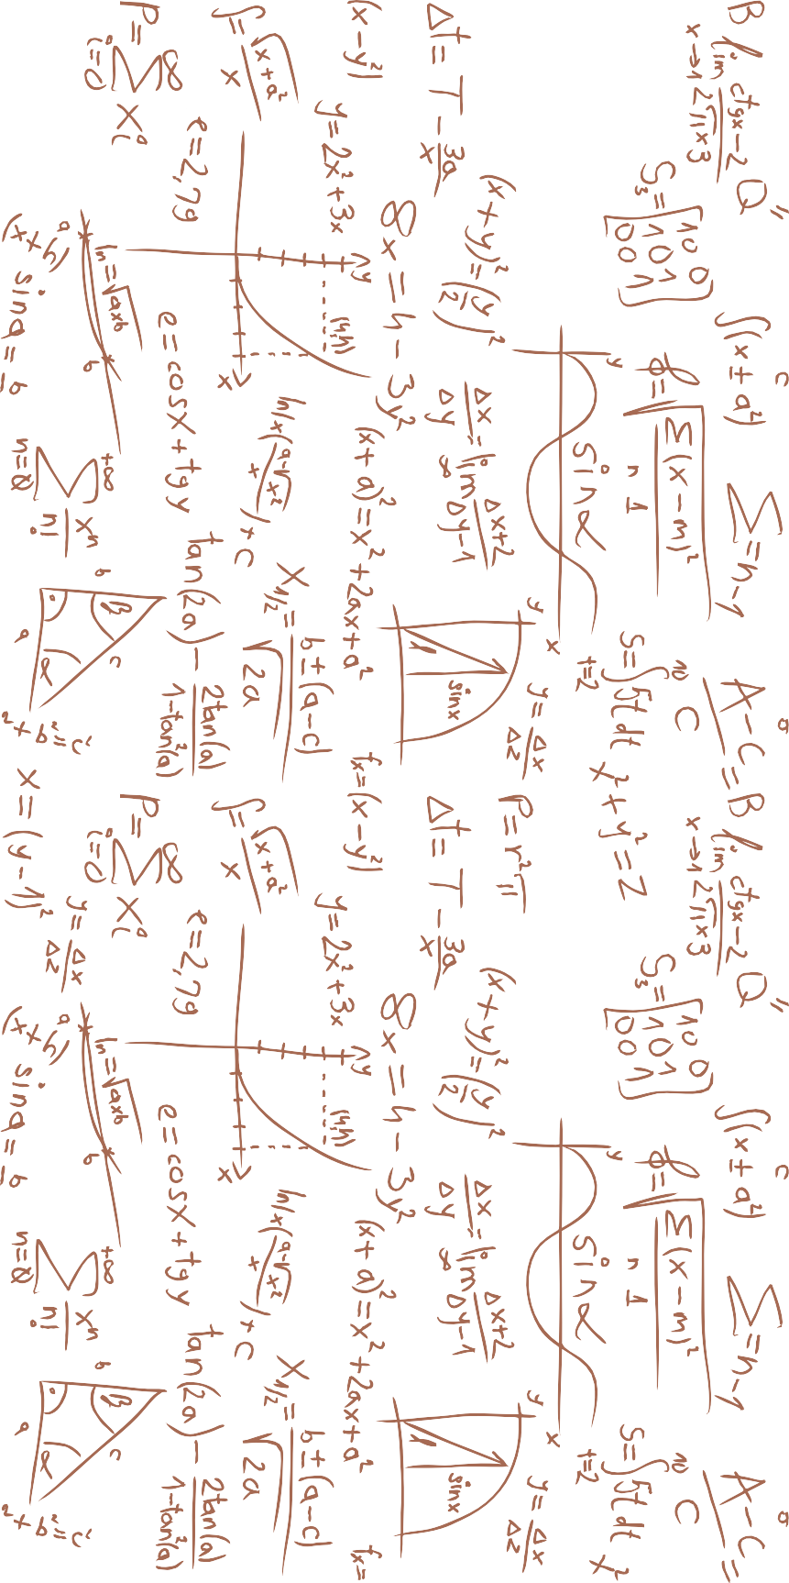

 I E D A T A S C I E N C E B O O T C A M P P T J A N - 2 0 2 1 

**L O C A T I O N O F W E A T H E R S T A T I O N S W I T H I N T H E B A S Q U E C O U N T R Y**

P R E S E N T A T I O N

J A N - 2 0 2 1

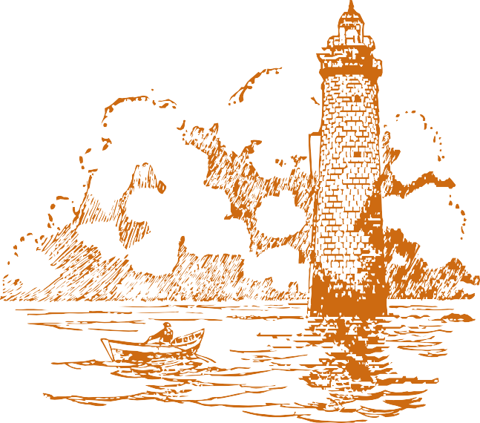

**Only 30% weather stations lie within the Biscay Province.**

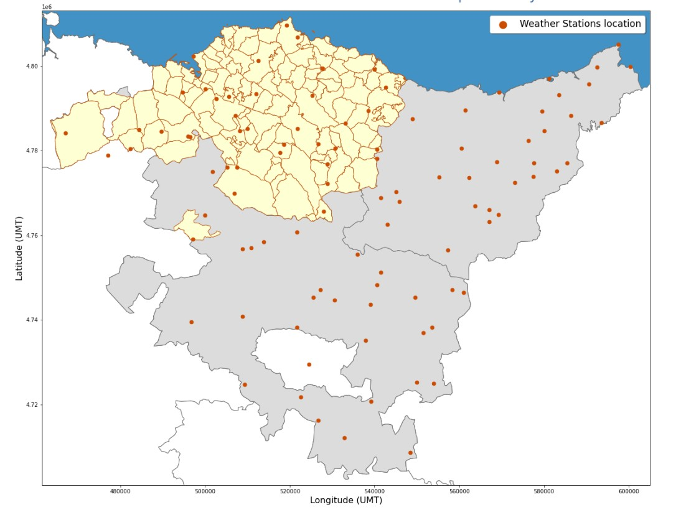

E X P L O R A T O R Y

D A T A

A N A L Y S I S

( E D A )

I E D A T A

S C I E N C E B O O T C A

M P P T

**25% of Biscay Municipalities lack a Weather Station.**



**W E A T H E R S T A T I O N S A S S I G N E D T O B I S C A Y M U N I C I P A L I T I E S**

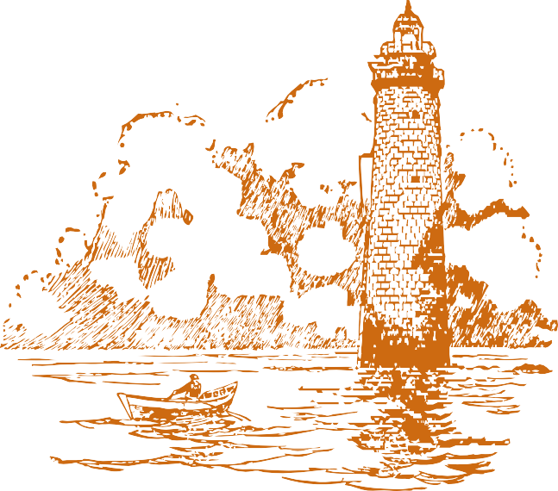

**All 112 Municipalities have been assigned the closest Weather Station.**

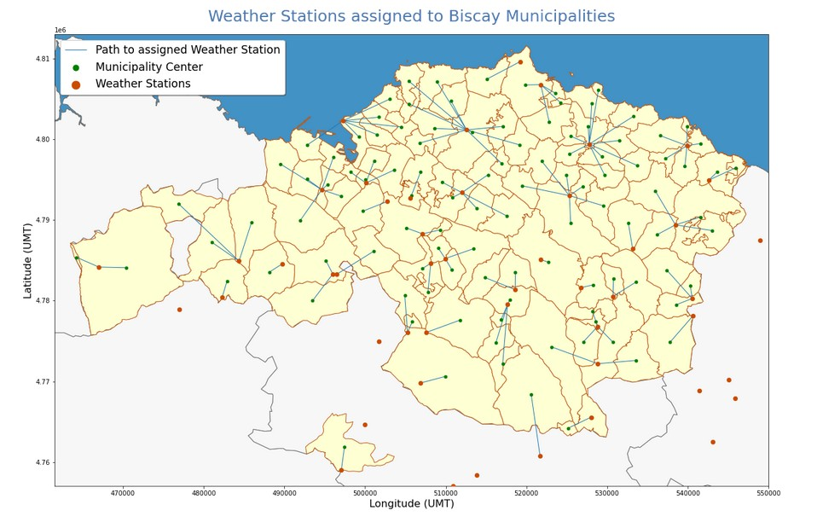

E X P L O R A T O R Y

D A T A

A N A L Y S I S

( E D A )

P R E S E N T A T I O N

I E D A T A

S C I E N C E B O O T C A

M P P T

J A N - 2 0 2 1

**This will allow to have more accurate weather data for our model.**



 E X P L O R A T O R Y D A T A A N A L Y S I S ( E D A ) P R E S E N T A T I O N 

H O W

T O

D E A L

M I S S I N G

V A L U E S ?

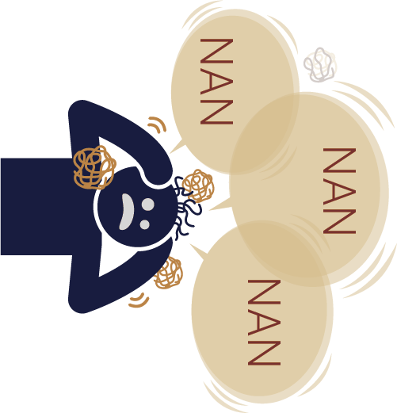

 I E D A T A S C I E N C E B O O T C A M P P T J A N - 2 0 2 1 

W I T H

 E X P L O R A T O R Y D A T A A N A L Y S I S ( E D A ) P R E S E N T A T I O N 

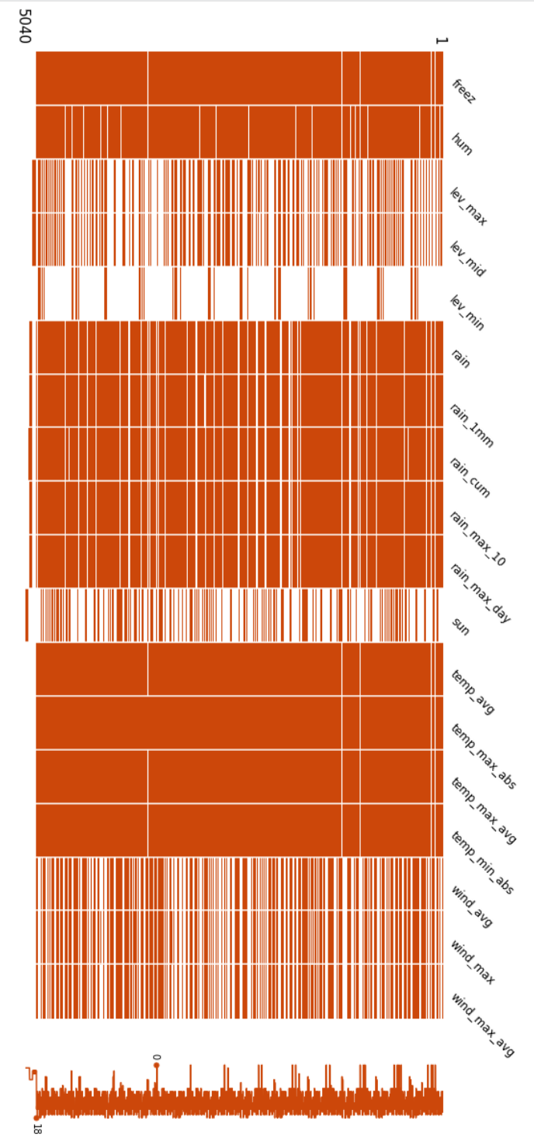

**C O M P L E T E N E S S**

**A N A L Y S I S**

**O F**

**W E A T H E R**

**D A T A**

 I E D A T A S C I E N C E B O O T C A M P P T J A N - 2 0 2 1 

 

**1364**

**On average per column**

**24 558**

**Total NaN values**

**5 040**

**Total rows**

E X P L O R A T O R Y

D A T A

A N A L Y S I S

( E D A )

P R E S E N T A T I O N

I E D A T A

S C I E N C E B O O T C A

M P P T

J A N - 2 0 2 1

## M I S S I N G V A L U E S I N S T A T I O N S D A T A

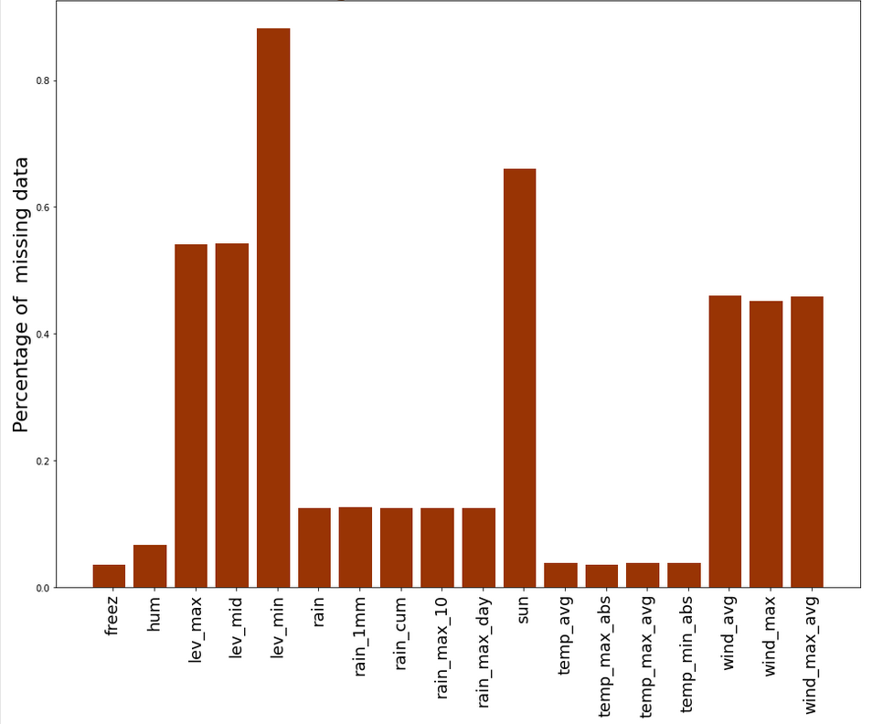

**18**

**Columns**

**27%**

**On average per column**



 E X P L O R A T O R Y D A T A A N A L Y S I S ( E D A ) P R E S E N T A T I O N 

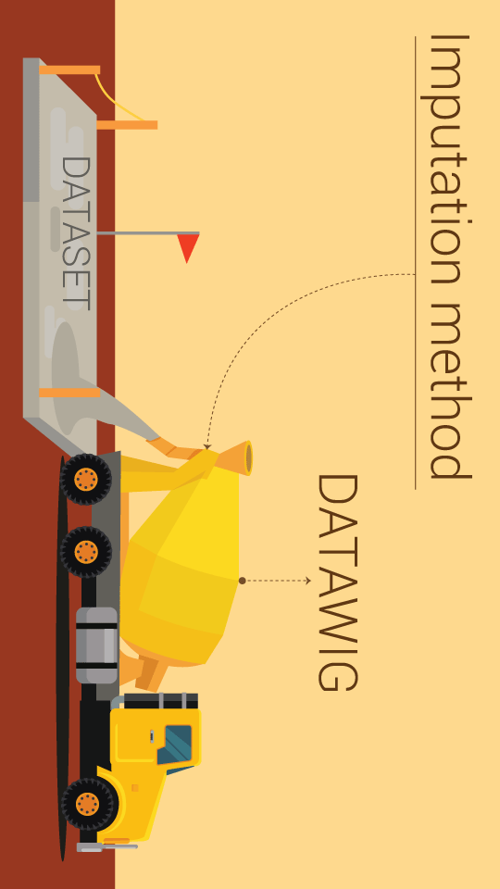

 I E D A T A S C I E N C E B O O T C A M P P T J A N - 2 0 2 1 

 E X P L O R A T O R Y D A T A A N A L Y S I S ( E D A ) P R E S E N T A T I O N 

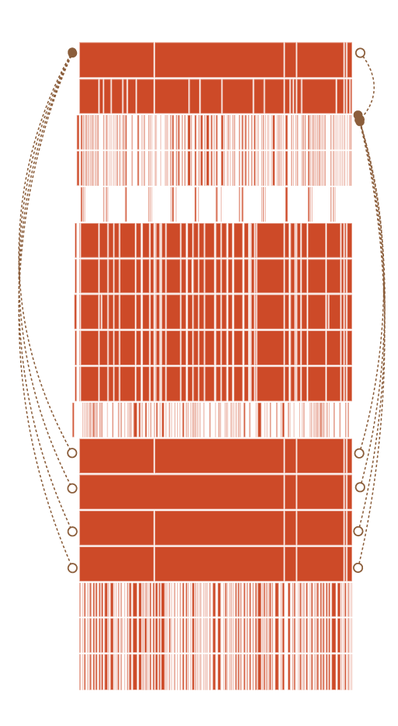

**I M P U T A T I O N**

**P R O C E S S**

**Imputed variable**

**Variables to impute**

 I E D A T A S C I E N C E B O O T C A M P P T J A N - 2 0 2 1 

 

P R E S E N T A T I O N

J A N - 2 0 2 1

K E E P C A L M A N D D A T A S C I E N C E

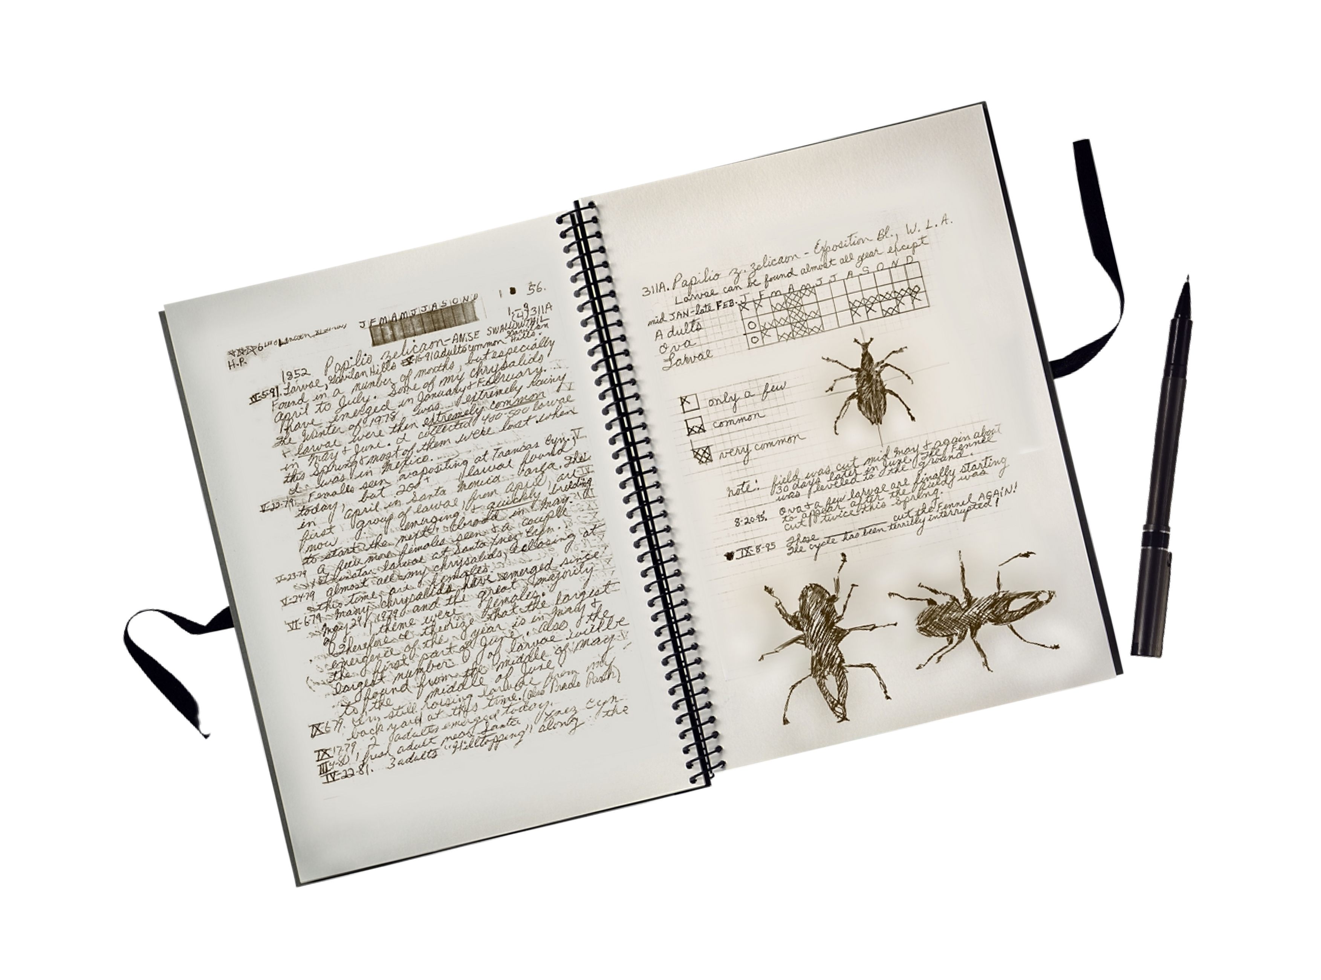

E X P L O R A T O R Y

D A T A

A N A L Y S I S

( E D A )

I E D A T A

S C I E N C E B O O T C A

M P P T

|  |  |
| --- | --- |
|  | **Next challenge: What to do about Bilbao (no data)** |
|  | **Prediction: What to feed The Machine** |
|  | **To have an impact: "Mean Square Error" and Dashboard** |



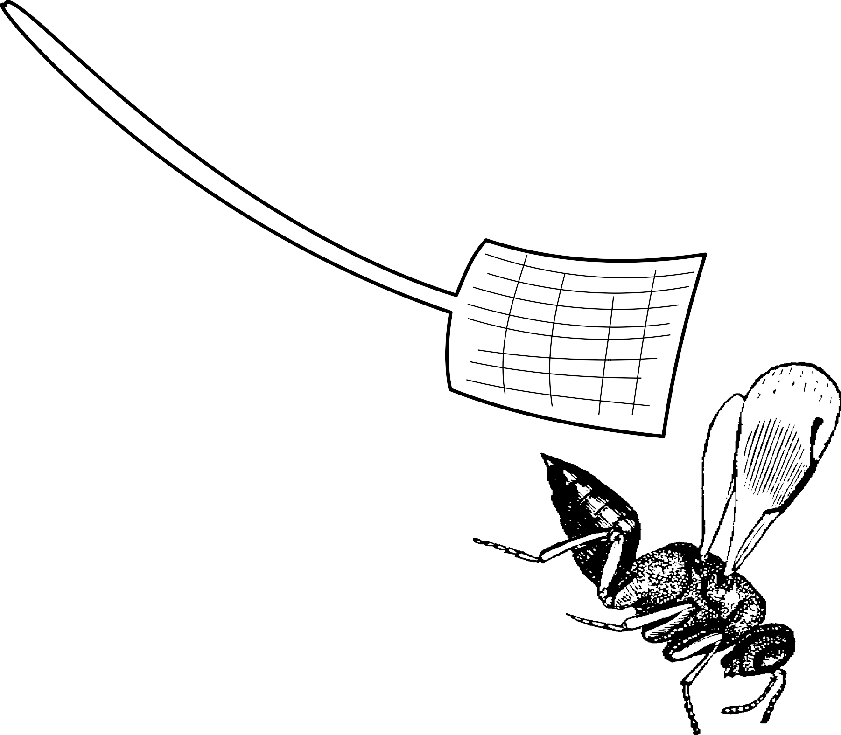 E X P L O R A T O R Y D A T A A N A L Y S I S ( E D A ) P R E S E N T A T I O N 

L E T ' S

B U S T

S O M E

W A S P S !

 I E D A T A S C I E N C E B O O T C A M P P T J A N - 2 0 2 1 

I E

X

L

D A T A S C I E N C E T E A M

H T T P S : / / G I T H U B

. C O M / I E W A S P B U S T E R S

 E X P L O R A T O R Y D A T A A N A L Y S I S ( E D A ) P R E S E N T A T I O N 

A N N E X E S

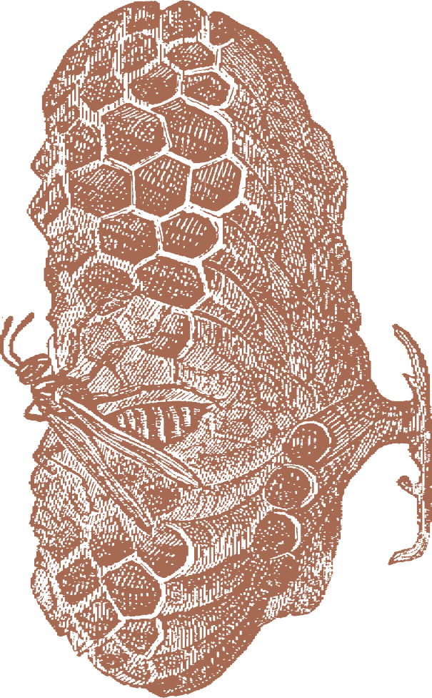 I E D A T A S C I E N C E B O O T C A M P P T J A N - 2 0 2 1 

 E X P L O R A T O R Y D A T A A N A L Y S I S ( E D A ) P R E S E N T A T I O N 

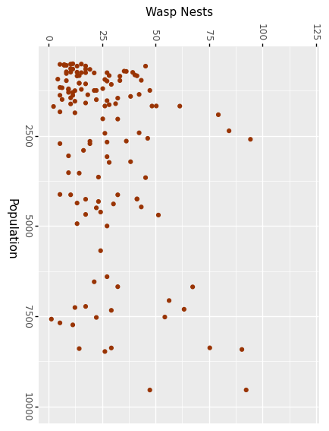

**N E S T S**

**V S**

**M U N I C .**

**P O P U L A T I O N**

 I E D A T A S C I E N C E B O O T C A M P P T J A N - 2 0 2 1 

 E X P L O R A T O R Y D A T A A N A L Y S I S ( E D A ) P R E S E N T A T I O N 

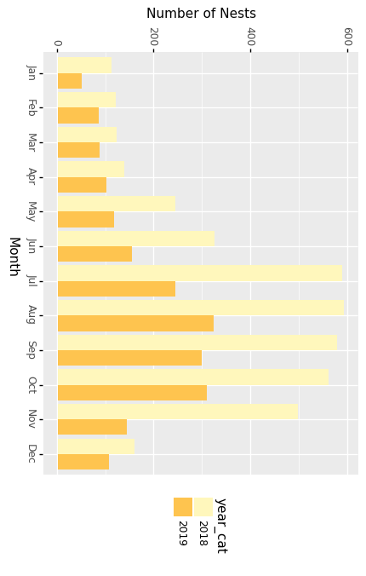

**A M O U N T**

**O F**

**R E P O R T E D**

**N E S T S**

**B Y**

**M O N T H**

 I E D A T A S C I E N C E B O O T C A M P P T J A N - 2 0 2 1 

 

D A T A

A N A L Y S I S

( E D A )

P R E S E N T A T I O N

S C I E N C E B O O T C A

M P P T

J A N - 2 0 2 1

## D I S P E R S I O N O F R E P O R T E D N E S T S L O C A T I O N

**R e p o r t e d n e s t l o c a t i o n s d o n o t c h a n g e d r a s t i c a l l y p e r y e a r a n d t e n d t o p r o l i f e r a t e a r o u n d c e r t a i n a r e a s .**

E X P L O R A T O R Y

I E D A T A



## W A S P N E S T L O C A T I O N S V S F O R E S T A R E A S I N T H E B I S C A Y P R O V I N C E P E R Y E A R

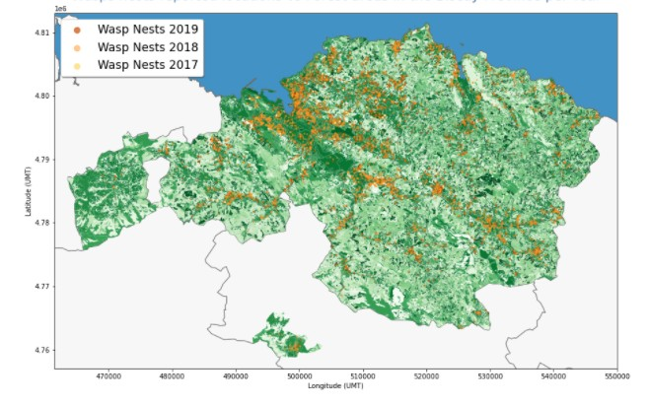

E X P L O R A T O R Y

D A T A

A N A L Y S I S

( E D A )

P R E S E N T A T I O N

I E D A T A

S C I E N C E B O O T C A

M P P T

J A N - 2 0 2 1

**P r o l i f e r a t i o n o f n e s t s a r o u n d d e n s e f o r e s t a r e a s - > W a s p s s e e k s h e l t e r**

